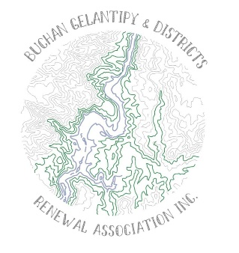
AGM
Friday 12th of April 2024 at the
Buchan Mechanics Hall at 6:00pm

Presidents Report

The last twelve months has been a culminating phase of some of our earlier work, sorting and implementing some of our community’s renewal goals. In the first 3 years we have worked to establish priorities and resource the priorities with clubs and community organisations working alongside the renewal committee. The community was once again in the line of a natural disaster with a flash flooding event that was devastating, both due to the loss of life and livelihood in both the economic and social dimensions of our catchment. The true cost to the community whilst intangible in many ways is still being felt especially by our businesses and organisations.
The ongoing challenges and complexities facing Buchan’s recovery has necessitated lengthy negotiation phases and processes. Regular communications with Clubs, Organisations, external stakeholders and agencies such as East Gippsland Shire Council and Emergency Vic to name the most common touch points. I would like to thank all parties for the good faith and persistence they continue to show, and for the leadership of our local people and Renewal Committee as we toil through these challenges.
The Renewal Committee have focused on a great deal of negotiation around our priorities of the rec Redevelopment, Community Playground and Tourism Offerings.
The recovery process for locations impacted by the fires is not finished yet as we start to identify some collateral impacts to our community post fire, a drawn-out pandemic period and most recently the Flash Flood event, which upset social and economic recovery processes. Key emerging issues include;
- Reduced economy and visitor investment for the fourth year running, with this being the quietest summer in our catchment that many of us can recall
- Challenges to rebuild and attract trades people.
- Reduced housing availability in the local area
- Record low levels of rental availability
- Dwindling local workforce and increased average working hours across households
- Clubs and social groups are identifying shortages of volunteers and players
We have successfully published the Community Renewal Plan and with tireless work from our secretary, Susan Freeman we have successfully finalized a number of smaller projects across the catchment which you may see some documentation around the hall tonight highlighting these works. We welcome and invite continued feedback from our broader community on the issues as they arise. We continue to facilitate public meetings around priorities and have co-created a number of working parties who are deeply engaged in managing the operational implementation of projects we are working on in the community.

New and finishing Committee Members:
The Renewal committee is entering into it’s fifth year of operating. We would like to thank our committee members who have decided across the course of the year to resign for all their Tieless work and recognize that all of this been done for the betterment of our community in a volunteer capacity. So again I thank the committee both the existing members and the retired members. The committee is actively seeking new committee members and encourage anyone with an interest in supporting the community by volunteering to assist in efforts to renew after the challenges of the past few years. We are aware that the designated funding will cease in June 2025 for fire related funding. This gives us a window of 14 months to consolidate the projects and seek the funding which remains to resource our communities needs.
Foci going forward include:
- Recreation Ground redevelopment
- Play space identification and planning
- Tourism Offerings including several concurrent projects

Future funding and opportunities to continue holding community gathering events:
The CRC is actively pursuing a series of community resilience grants to continue to maintain and upgrade our community facilities. There are multiple projects that have received funding or have been approved as projects that can be planned and made shovel ready for funding. The CRC is a pivotal conduit to accessing funding and is often sort to float opportunities that community groups can apply to. We encourage all local groups to continue working with our committee and Susan our community Project and liaison officer to pursue grants that will assist in the communities ongoing resilience and recovery.

We Know there are many challenges, however we are committee to the priorities and encourage our community to continue to work with as we work hard to finish this journey on a strong note as we seek to maximize the resourcing we can attract in this final period.
Yours Sincerely,
Katie Hodge
Chairperson
Buchan Gelantipy and Districts Renewal Committee

