Buchan, Gelantipy and Districts Renewal Association (Incorporated)
Agenda
Venue: online only via Zoom
Date: 22/06/2021
Meeting time 6pm
Invitees:
Committee: D Graham, K Hodge, J Coates, Anne Brewer, K Pearce, Donna Mraz
Council Representatives: S Healy, E Aldersea
Guests:
Gallery:
Apologies: J Sutton, G Brick, A Henderson, C Cooper

Minutes of meeting: Minutes from 25 May, Moved by Kirstie, Seconded by Donald

Business arising from minutes:
- Letter to BRV has been sent
- Working group for the pillars has happened
- LER review – documentation via email to the CRC Chairs, the next round will be a grant-based round despite the feedback from CRCs that this isn’t working
  - Will likely be delayed
- Parks Vic update included in the Phoenix this month
- Action: Need to decide on a date to strategically plan for next round of grants etc
- Flow chart with community engagement went into this month’s Phoenix
  - Action: A4 print outs to be put up around town noticeboards later this week

Treasurers Report:
Balance: $83,624 in business account
- See Treasurer’s Report below
- Moved by Kirstie, seconded by Donna

General Business:

- Follow up from Parks Vic conversation (Kate)
  - Phil’s email about One Tree Hill (sent with meeting info)
    - Janice: suggestion put to her by community members that it would be nice to recognise John Brownridge. One Tree Hill has been a popular picnic point, nice to get tables and infrastructure re-instated.
    - Kate is concerned about just focussing on John’s contribution, suggesting we find a way to feature John and more of the story of the area as well. A historical story of the area through the signage.
    - Donald and Anne don’t see a need to change the name of the hill.
    - Action: Use concept of recognising historical periods for interpretive signage, featuring John’s contribution to forestry and fire management
      - Kate to write letter to Parks Vic stating we’re happy for them to provide picnic tables, bbq and historical/interpretive signage recognising the history and John Brownridge’s contribution to the forestry and fire management. CRC will work to put together the information needed for signage (Kate has some existing information to provide to Parks Vic)
        - Two picnic tables and a BBQ required
      - Janice will contact John to find out his choice of tree
        - New native tree to be planted
  - Bridge update
    - Temporary measure to be put in place as soon as possible
- Community Renewal Plan development (Suzie)
  - Pillars list
    - Send document to everyone today with everything collated, about 90% pulled together
    - Action: committee to provide feedback over the next week
      - This will be useful for Suzie to use in the development of the renewal plan
  - Proposal for plan development
    - Suzie proposing that she takes on writing the plan and will bring back to committee to check through rather than engaging a consultant which will be time consuming
    - All agreed Suzie can take on this work
    - Action: Suzie to draw up project plan and send out before next meeting to committee
- Telecomms project update (Suzie)
  - The survey closed on Friday last week, good response across the district. Results to be packaged up and sent to consultant. Suzie has requested the Buchan results on their own, along with the municipality wide results.
  - Engaging Chris Mathers to provide input on behalf of committee
    - Suzie has linked up Chris with the consultant but not news yet
    - Chris should be reimbursed for his time to talk to the consultant
    - Motion: Committee endorsed engaging Chris Mathers to provide input for the telecoms project and he will be reimbursed for his time by the committee (max: $500). Moved by Kirstie, seconded by Anne
- Streetscape project update (Suzie and Anne)
  - See Fact Sheet attached to meeting info
  - Website link: https://buchandistrictsrenewal.com.au/index.php/buchan-main-street-and-linkages-project/
  - The project has committed to providing an update in the Phoenix when there is something to update, first update went in this month’s issue
  - All land owners in the Main St will be contacted in the coming weeks (Erin and Suzie to do)
  - Updates to be included on the Facebook page as well
  - We had meeting last month and one coming up on Friday
  - The streetscape and walking track will be separate projects, walking track to progress on its own. Civil engineer contracted (Neil Streeter)
  - Consultants have been appointed to manage the activation part of the project, they are coming to Friday’s meeting this week
  - Proactive engagement to begin in July, a lot of community consultation along the way
- Donation to school and kinder (Kirstie)
  - Kirstie remembers the discussions around this decision ($1500 to each)
  - Also discussed donating $3000 to youth programs, this hasn’t happened yet
  - No motion moved at the time in minutes
  - $1500 to be donated each to school and kindergarten, also $3000 to youth programs. To be used for tools to aid in children’s learning.
  - Motion: Committee endorsed donation of $1500 to kindergarten and school and $3000 pledge to youth based programs. Moved by Kirstie, seconded by Donald.
- Tourism Opportunity Plan update (Suzie)
  - This is one of the three priorities
  - This project is being run in 3 districts (Erinunderra to Snowy, Cann Valley and Buchan)
  - See purpose and brief below agenda
  - Call for representatives from committee (2 needed)
    - Kirstie already nominated
    - Donald nominated (or Chris)
    - Kate is going to ask Chris Cooper if he’s interested
  - Call out for community representation (4 needed)
    - Kate thinks we need to get someone from north of Buchan is needed
    - New café owners might be interested and W Tree Sunrise Enterprises
    - Action: call out to community members through our communication channels – Facebook, email members
- Working groups needed:
  - Budget/planning team
    - Kate, Kirstie and Anne nominated to join this working group
  - Planning group for the park consultation
    - Donald, Kate and Donna nominated
- Three priorities update (Suzie)
  - Play Space project
    - Developed a request for quote, handed over to BRV, exception approved to find someone off the panel
    - 8 designers have received a request for quote – due 9 July
  - Rec Reserve
    - Land ownership element
      - Suzie has written a report to support Buchan community to look at options for land purchase, to be presented to Council

Next meeting: Thursday 22 July
Meeting closed: 7:10pm
Minutes written by: Erin Aldersea
Chairperson: K Hodge
Signed:
Date:
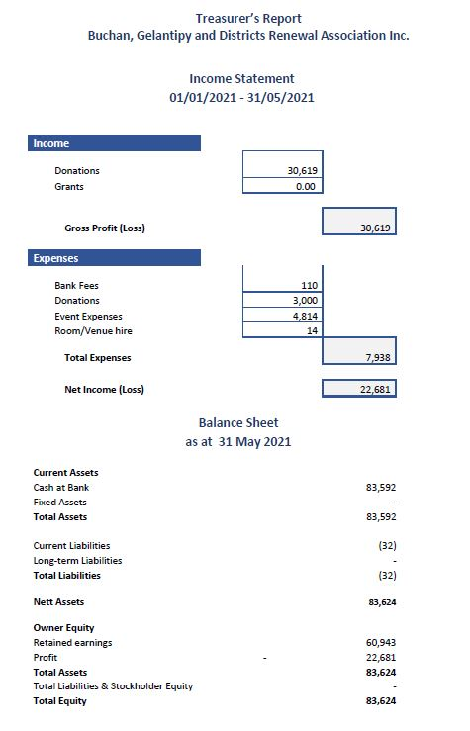
Treasurer’s Report

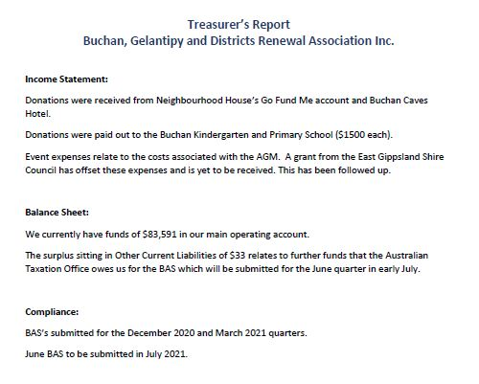

Tourism Opportunity Plan purpose
